Help with Measuring Jackets
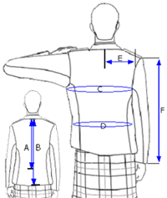
Jacket Length
A) For Prince Charlie Jackets measure length from the nape of the neck to waist, just above top of hips
B) For Argyll and Crail Jackets, measure from the nape of the neck to the base of the spine, just above the seat.
C) Chest
Measure loosely around chest at under arm height while wearing a shirt/vest (no jacket), with arms by the sides. Do not inflate chest.
D) Waist
Measure around waist above hip bone while wearing a shirt/vest (no jacket).
E) Half Back
Measure from centre back, centre seam on a well fitting jacket, at 6" below the bottom of the collar to shoulder seam, arms by sides.
F) Sleeve Length
Measure from shoulder seam to cuff, if sleeve is desired to be long or short add/remove 1/2" to standard length. Standard length shows up to 1" of shirt cuff.

